|  |  |  |  |  |  |
| --- | --- | --- | --- | --- | --- |
| Date | December 13, 2022 | | | Tester Name | Syed Shahabuddin |
| Environment | Penfax - Test | | | Login used |  |
| Operating System | Windows | Version: | Update: | | |
| Software Used | Edge | Version: | Update: | | |
| Select Software | Version: | Update: | | |
| Release version | 22.4.1 | | | | |
| Title | E23.16 | | | | |
| Test Type | Regression | | | | |
| Test Scenario | Process PEPP payment distribution batch | | | | |
|  |  | | | | |
| Expected Results | Verify the batch run successfully and letters generated and saved on member communications  Process a number of different types of payments (LIRA transfer, Cash term payment, VPB Lump Sum, Death payments, SRB payments, etc) | | | | |
| Pass/Fail | Pass | | | JIRA# | N/A |

Member Search:

* PEPP, employee and deferred
* SRB payment any PEPP member
* VPB member type for VPB payments

Member list to confirm batch included all payments:

|  |  |  |  |
| --- | --- | --- | --- |
| Stakeholder | Type of payment | Retire/term (over 50/under) | Batch and letters successful |
| 258661 | Cash | Term |  |
| 302728 | LIRA (2 FI’s) | Retire |  |
| 258669 | Cash (partial) | Retire |  |
| 280602 | RRSP | Term |  |
| 128467 | SRB to spouse | SRB (added SIN & address to spouse) |  |
| 341242 (299191) | Death to spouse (cash) | Spouse USA resident (added SIN) |  |
| 253278 | Vpb lump sum | VPB NET pmt |  |
| 258664 | VPB to outside annuity | 200k gross |  |

Above payments were processed, will confirm results tomorrow.

Batch ran successfully:

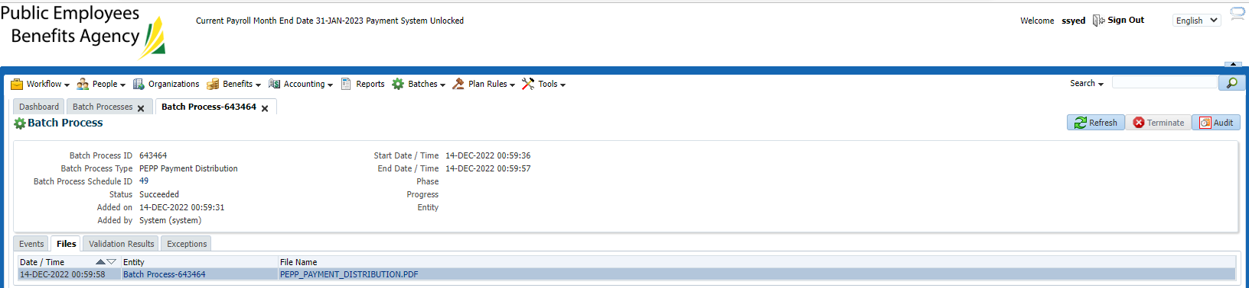

Payments above shot up on report. Tax is reported & reasonable.

